BENCHMARKING DISTRIBUTED COMPUTING FRAMEWORKS: PERFORMANCE EVALUATION OF SPARK, H2O, DASK, AND RAY ON COMMODITY HARDWARE ENVIRONMENTS



BY:
PUTU RADITIA SATRIAWAN
NIM. 2315101005

COMPUTER SCIENCE STUDY PROGRAM
DEPARTMENT OF INFORMATICS ENGINEERING
FACULTY OF ENGINEERING AND VOCATIONAL
GANESHA UNIVERSITY OF EDUCATION
SINGARAJA
2026

ACKNOWLEDGEMENT
First and foremost, the author would like to express the deepest gratitude to God Almighty for His blessings, grace, strength, and guidance, which have enabled the author to complete this undergraduate thesis successfully. Without His mercy and continuous support, the completion of this research would not have been possible. This thesis entitled “Benchmarking Distributed Computing Frameworks: Performance Evaluation of Spark, H2O, Dask, and Ray on Commodity Hardware Environments” is submitted as a requirement for obtaining a Bachelor’s Degree in the Computer Science, Faculty of Engineering and Vocational, Ganesha University of Education.
The author realizes that the completion of this thesis would not have been achieved without the assistance, encouragement, and support from many individuals and institutions. Therefore, with sincere respect and appreciation, the author would like to express heartfelt gratitude to:
- Prof. Dr. I Wayan Lasmawan, M.Pd., Rector of Ganesha University of Education, for providing the academic environment and institutional support that facilitated the author’s learning process.
- Prof. Dr. Kadek Rihendra Dantes, S.T., M.T., Dean of the Faculty of Engineering and Vocational, Ganesha University of Education, for the leadership and support provided to students in pursuing academic excellence.
- I Nyoman Saputra Wahyu Wijaya, S.Kom., M.Cs., Head of the Computer Science study program, and also author’s academic counselors, for guidance, academic direction, and administrative support throughout the author’s study period.
- I Made Putrama, S.T., M.Tech., Ph.D., as the First Supervisor, for the continuous guidance, patience, constructive feedback, and valuable insights throughout every stage of this research process.
- Kadek Yota Ernanda Aryanto, S.Kom., M.T., Ph.D., as the Second Supervisor, for the invaluable advice, critical evaluation, and continuous encouragement that significantly helped shape and refine the quality of this research.
- The technicians, laboratory staff, and fellow researchers at the IoT Laboratory, Faculty of Engineering and Vocational, Ganesha University of Education, for providing the computer cluster infrastructure, technical assistance, and collaborative environment.
- The author’s beloved parents and family, whose endless prayers, unconditional love, moral encouragement, and material support have become the greatest source of motivation and strength throughout the academic journey.
- All friends, classmates, and colleagues who have provided encouragement, discussion, and companionship during the completion of this study.
The author fully realizes that this thesis is far from perfect and may still contain limitations and shortcomings. It is the author’s sincere hope that this research will provide meaningful contributions and become a useful reference for future studies, particularly in the field of distributed computing and performance benchmarking.

Singaraja, May 2026

Putu Raditia Satriawan

ARTIFICIAL INTELLIGENCE (AI) USE STATEMENT
I hereby declare that in preparing this thesis, I used a Large Language Model (LLM) which are Google Gemini, ChatGPT, and Grammarly, solely as a virtual assistant for the following purposes:
- Grammar checking and sentence editing in English.
- Translating academic literature for the purposes of understanding the literature review.
- Assisting in troubleshooting and debugging basic code scripts during the testing phase.
I confirm that artificial intelligence was not used to generate research data, analyze final experimental results, or formulate academic conclusions. All computational data, test matrices, and the substance of the ideas in this thesis are purely the result of my own intellectual work and experiments. I take full responsibility for the entire content and validity of this document.

LIST OF CONTENTS
PAGE
ACKNOWLEDGEMENT ii
ARTIFICIAL INTELLIGENCE (AI) USE STATEMENT iv
LIST OF CONTENTS v
LIST OF TABLES viii
LIST OF FIGURES ix

CHAPTER 1 INTRODUCTION 1
1.1 Background of the Study 1
1.2 Problem Identification 4
1.3 Scope of the Study 5
1.4 Statement of the Problem 6
1.5 Objectives of the Study 7

CHAPTER 2 LITERATURE REVIEW 9
2.1 Theoretical Framework 9
2.1.1 Distributed Computing in Commodity Environments 9
2.1.2 Hadoop Distributed File System (HDFS) 10
2.1.3 State-of-the-Art of Distributed Frameworks 10
2.1.4 Overview of the Evaluated Frameworks 12
2.1.4.1 Apache Spark 12
2.1.4.2 H2O.ai 13
2.1.4.3 Dask 13
2.1.4.4 Ray 13
2.1.5 Benchmarking Metrics 14
2.1.5.1 Success Rate 14
2.1.5.2 PAR-10 (Penalized Average Runtime) 15
2.1.5.3 Geometric Mean of Speedup (GMS) 16
2.1.5.4 Dolan–Moré Performance Profiles 17
2.1.5.5 Friedman Test (Omnibus Test) 18
2.1.5.6 Pairwise Wilcoxon Signed-Rank Test with Holm-Bonferroni Correction 19
2.2 Review of Related Literature 20
2.2.1 Comparative Studies on Distributed Frameworks 20
2.2.2 Architectural Evaluation and Framework-Specific Optimizations 22
2.2.3 Statistical Methodologies and Commodity Infrastructure 23
2.2.4 Research Gap and Novelty of the Study 24

CHAPTER 3 RESEARCH METHODOLOGY 10
3.1 Research Design 10
3.2 Research Setting and Hardware Specification 10
3.2.1 Master Node Specification (1 Node) 10
3.2.2 Worker Nodes Specification (5 Nodes) 26
3.3 Dataset Specification and Workload Design 26
3.4 Research Variables 29
3.4.1 Independent Variables 29
3.4.2 Dependent Variables 29
3.5 Systematic Stages of Research 29
3.6 Execution and Data Collection Procedures 32
3.7 Data Analysis Procedures 33
3.7.1 Success Rate Calculation 33
3.7.2 Geometric Mean of Speedup (GMS) with PAR-10 Penalization 33
3.7.3 Dolan–Moré Performance Profile Construction 33
3.7.4 Inferential Statistical Testing (Hypothesis Testing) 34
3.7.5 Justification of the Analytical Workflow 34
3.8 Threats to Validity 35
3.9 Research Schedule 36

CHAPTER 4 RESULTS AND DISCUSSION 37
4.1 Cluster Infrastructure and Experimental Environment 37
4.2 Framework Reliability and Success Rate 39
4.3 Parallel Scalability (GMS) Analysis 40
4.4 Dolan-Moré Performance Profiles 41
4.5 Inferential Statistical Analysis 43
4.5.1 Omnibus Test: Friedman Test 43
4.5.2 Post-Hoc Analysis: Pairwise Wilcoxon Signed-Rank Test 44
4.6 Setup Complexity and Operational Usability 45
4.7 Holistic Discussion of Experimental Findings 47

CHAPTER 5 CONCLUSION AND RECOMMENDATIONS 38
5.1 Conclusion 38
5.2 Recommendation 51

REFERENCES 53

LIST OF TABLES
PAGE
Table 2.1 Capability Comparison of Distributed Frameworks 12
Table 3.1 HEPMASS Dataset (10 First Rows) 27
Table 3.2 Research Schedule 36
Table 4.1 Framework Reliability and Success Rate 39
Table 4.2 Geometric Mean of Speedup (PAR-10 Adjusted) 40
Table 4.3 Pairwise Wilcoxon Signed-Rank Test Results (Holm Adjusted) 45

LIST OF FIGURES
PAGE
Figure 3.1 Stages of Research Flowchart 30
Figure 3.2 Combinations of Configurations of the Execution 31
Figure 4.1 Physical Implementation of the Heterogeneous Commodity Cluster 37
Figure 4.2 Cascaded Network Topology Utilizing Interconnected Commodity Routers 38
Figure 4.3 Dolan-Moré Performance Profiles (5 Slaves) 41

CHAPTER 1
INTRODUCTION

1.1 Background of the Study
The exponential growth of digital data in recent years has transformed the landscape of scientific research, industry, and public services. The proliferation of Internet of Things (IoT) devices, social media platforms, enterprise systems, and cloud-based applications has resulted in the generation of massive volumes of structured and unstructured data, commonly referred to as Big Data. Traditional single-machine data processing approaches are increasingly inadequate to handle the velocity, volume, and variety of such data, particularly in complex domains such as IoT-driven healthcare analytics (Šajnović et al., 2024). Consequently, distributed computing has emerged as a fundamental paradigm that enables parallel data processing across multiple nodes in a cluster, thereby overcoming traditional computational bottlenecks and significantly improving scalability, performance, and fault tolerance (Bin Yusof, 2023).
In academic and research environments, the demand for high-performance computing is growing rapidly, yet it is frequently hindered by strict budget constraints and limited access to enterprise-grade supercomputers. Universities often possess numerous commodity desktop computers in their laboratories. Individually, these machines may lack the computational power and memory required for complex data analytics, leading to severe underutilization or them being left idle. However, combining these existing, standard-specification desktop computers into a unified distributed cluster presents a highly cost-effective solution.
The demand for High-Performance Computing (HPC) is no longer exclusive to elite enterprise laboratories. In modern academic settings, tasks such as training complex machine learning models or processing massive tabular datasets continuously exceed the capabilities of standalone commodity machines. To address this, maximizing existing academic IT infrastructure becomes crucial. This study specifically utilizes the available, standard-specification desktop computers housed within the FTK Undiksha IoT Laboratory to evaluate how these constrained, everyday academic resources can be repurposed into a functional distributed cluster for general-purpose big data analytics. This approach not only prevents hardware underutilization but also transforms constrained devices into a capable distributed system, providing researchers and students with the necessary infrastructure to process large-scale datasets locally.
The accelerating pace of digital transformation across multidisciplinary research fields has led to a massive influx of complex data environments within modern academic institutions. At Ganesha University of Education, this digital expansion is prominently manifested in various high-impact platforms, ranging from web-based agricultural tracking applications (L. J. E. Dewi et al., 2021) and mobile-driven patient registration architectures (Seputra & Dewi, 2022), to innovative smartphone-based health intervention models (Dantes et al., 2024). The integration of advanced localized technologies, such as IoT-based physical monitoring systems (Aryanto et al., 2021) and QR-assisted geotagging inventory frameworks (Setemen et al., 2020), continuously amplifies the university's data accumulation. Processing and resolving these massive operational workloads introduce profound computational bottlenecks, particularly when dealing with the core structural integration of highly heterogeneous data frameworks (Putrama & Martinek, 2024) or executing heavy deep-learning algorithms for satellite-based remote sensing grid analysis (N. P. K. Dewi et al., 2025). While scaling these distributed workloads is imperative, academic laboratories frequently encounter severe budgetary boundaries. Consequently, finding a resource-resilient methodology to execute these data-intensive tasks on existing commodity hardware remains a critical infrastructure challenge.
While transforming commodity hardware into a distributed cluster solves the physical resource problem, selecting the appropriate distributed computing framework becomes a critical challenge. Traditional big data frameworks are often resource-intensive and designed for enterprise-grade servers, making them prone to instability or out-of-memory errors on constrained hardware. Therefore, there is a pressing need for lightweight, stable, and robust frameworks that can operate efficiently within these hardware limitations. Several frameworks have been developed with distinct characteristics. Apache Spark is widely recognized for its in-memory processing capabilities. However, its processing model can create burst traffic patterns and severe performance bottlenecks, significantly lowering throughput in resource-constrained environments (Kumar Alam, 2022). H2O provides a highly optimized platform for predictive analytics, yet its memory management can be rigid during massive data spikes. Dask, on the other hand, offers flexible parallel computing in Python and relies on dynamic task scheduling and out-of-core computation, making it highly resilient and capable of extending the effective scale of constrained hardware (Pauloski et al., 2024). Meanwhile, Ray focuses on distributed execution for machine learning workloads with a highly scalable architecture, though managing its resources and parallel processing overhead can vary depending on the specific distributed AI tasks (Poddar et al., 2025).
In environments like the IoT Laboratory at the Faculty of Engineering and Vocational (FTK), Ganesha University of Education (Undiksha), where cluster resources are limited and heterogeneous, framework selection often relies on anecdotal evidence or general industry reports that do not accurately reflect local performance conditions. Therefore, this study aims to perform a rigorous comparative benchmark analysis of Apache Spark, H2O, Dask, and Ray within the unused Commodity PC of IoT Laboratory cluster. By utilizing evaluation techniques such as the Geometric Mean of Speedup (GMS) and Dolan-Moré Performance Profiles, this research evaluates the efficiency, execution speed, and robustness of each framework.

1.2 Problem Identification
Based on the background described above, several specific problems can be identified:
- Researchers and students at FTK Undiksha lack empirical benchmark data comparing Apache Spark, H2O, Dask, and Ray within the unused IoT Laboratory Commodity Clustered PC.
- The limited memory and processing capacity of laboratory computers may cause frequent execution failures (e.g., Out of Memory or timeout errors), yet there is no systematic evaluation of framework robustness under such constraints.
- Existing benchmark studies often focus solely on execution time, neglecting multi-metric evaluations that include robustness, success rate, and penalized performance measures.
- There is insufficient guidance for selecting the most efficient and reliable framework for machine learning tasks in a medium-scale academic cluster setting.

1.3 Scope of the Study
This study is limited to a comparative benchmark analysis of four distributed computing frameworks: Apache Spark, H2O, Dask, and Ray. The evaluation will focus on their performance within the IoT Laboratory computer cluster at FTK Undiksha. The experimental workloads will consist of supervised machine learning tasks, specifically classification and regression.
The datasets used in this research will vary in size, ranging from small-scale datasets (500 rows) to larger datasets up to 1024 MB. This range is selected to simulate increasing computational complexity while remaining within the physical constraints of the laboratory cluster. The study will not evaluate cloud-based deployments, GPU acceleration, or other external infrastructures. Instead, it will strictly analyze performance within the existing on-premise cluster configuration.
The physical constraints of the IoT Laboratory cluster, including CPU specifications, memory capacity, storage type, and network bandwidth, will serve as fixed environmental parameters. Optimization techniques beyond standard configuration adjustments will not be the primary focus, as the objective is to evaluate baseline performance and robustness under realistic machine learning model’s development conditions.
The empirical evaluation is strictly tied to the specific commodity hardware configurations currently available and not used in the FTK Undiksha IoT Laboratory. It must be noted that while the physical infrastructure is sourced from this specific laboratory, the benchmark evaluates general-purpose distributed computing capabilities and is not restricted to, nor specifically evaluating, IoT-centric workloads. Consequently, the performance baselines observed may not be directly generalizable to enterprise-grade cloud environments.
To ensure a focused and measurable evaluation, the experimental workloads are restricted to two fundamental machine learning tasks: binary classification and regression. The benchmarking process utilizes the HEPMASS (High-Energy Physics Mass) dataset, which is strategically partitioned into four distinct sizes (500 rows, 1 million rows, 10 MB, and 1024 MB) to evaluate framework performance across both lightweight and memory-intensive scenarios.

1.4 Statement of the Problem
The research questions guiding this study are formulated as follows:
- Which distributed computing framework (Apache Spark, H2O, Dask, or Ray) demonstrates the highest success rate when executing classification and regression tasks in the IoT Laboratory cluster?
- Which framework provides the best overall performance based on the Geometric Mean of Speedup (GMS) when execution failures are penalized using the PAR-10 methodology?
- How do the frameworks compare in terms of efficiency and robustness as visualized through Dolan–Moré Performance Profiles?
- Are the observed performance differences among the distributed frameworks statistically significant when evaluated using the Friedman Test and Pairwise Wilcoxon Signed-Rank Test?
- What is a statistically proven recommendation regarding the most suitable distributed computing framework for machine learning use at FTK Undiksha?

1.5 Objectives of the Study
In alignment with the research questions, the objectives of this study are:
- To measure and compare the success rate of Apache Spark, H2O, Dask, and Ray under varying dataset sizes in the IoT Laboratory cluster.
- To compute and analyze the Geometric Mean of Speedup (GMS) for each framework, incorporating PAR-10 penalization to account for execution failures.
- To construct Dolan–Moré Performance Profiles in order to evaluate the trade-off between efficiency (speed) and robustness (reliability).
- To validate the statistical significance of performance differences using the Friedman Test as an omnibus test, followed by the Pairwise Wilcoxon Signed-Rank Test with Holm-Bonferroni correction for post-hoc analysis.
- To provide empirical, statistically proven recommendations regarding the most suitable distributed computing framework for machine learning use at FTK Undiksha.
- To promote sustainable IT practices and green computing by evaluating the feasibility of repurposing and reusing older, resource-constrained commodity computers within the laboratory into a highly functional distributed cluster.

CHAPTER 2
LITERATURE REVIEW

2.1 Theoretical Framework
This section establishes the foundational concepts and theoretical principles that underpin this study. Given the complexity of modern distributed systems, it is essential to systematically examine the core technologies and methodologies involved. Several theoretical are deeply explained to enhance understanding of this research

2.1.1 Distributed Computing in Commodity Environments
Recent advancements in distributed computing focus heavily on optimizing task scheduling, data partitioning, and fault tolerance (Šajnović et al., 2024). While the majority of current research evaluates distributed frameworks on enterprise-grade High-Performance Computing (HPC) environments or cloud infrastructures like AWS and Microsoft Azure (Bin Yusof, 2023), utilizing commodity hardware clusters remains a critical area of study. Commodity clusters, such as those found in university laboratories, present unique challenges including network latency, heterogeneous specifications, and severe memory constraints (Kumar Alam, 2022). Current literature emphasizes that deploying distributed systems on such resource-constrained nodes requires highly efficient resource scheduling to prevent hardware underutilization and system crashes, an area that is still underrepresented compared to enterprise cloud studies (Rocklin, 2015).

2.1.2 Hadoop Distributed File System (HDFS)
Before processing massive datasets using modern compute engines, a robust and highly available distributed storage mechanism is strictly required. According to Singh et al. (2023), while frameworks like Apache Spark and Ray excel at high-speed, in-memory data processing, they inherently lack a native, persistent distributed storage system. Therefore, Apache Hadoop is utilized exclusively as the foundational storage layer in this study (Singh et al., 2023).
Gupta et al. (2024) emphasized that HDFS remains the cornerstone of modern big data architectures due to its exceptional fault tolerance and data replication capabilities across commodity hardware. In this architecture, HDFS works by partitioning the massive HEPMASS dataset into smaller data blocks and distributing them across the worker nodes. It serves as the unified data backbone, allowing modern execution engines (Spark, H2O, Dask, and Ray) to access and retrieve data seamlessly and in parallel during the benchmarking process (Gupta et al., 2025).

2.1.3 State-of-the-Art of Distributed Frameworks
This study selects four specific frameworks because they represent the current SotA landscape:
- Apache Spark: The current industry standard and undisputed benchmark baseline for distributed computing (Zaharia et al., 2016).
- H2O.ai: The leading framework specifically optimized for distributed, in-memory Machine Learning and AutoML (Zöller & Huber, 2021).
- Dask: The most prominent Python-native framework designed to scale the traditional PyData ecosystem (Pandas/NumPy) without altering the user's code structure (Rocklin, 2015).
- Ray: The newest and highly aggressive distributed execution engine, originally developed by UC Berkeley, currently dominating modern AI and deep learning scaling workloads (Moritz et al., 2018).
Rather than merely serving as data processing engines, modern distributed frameworks exhibit distinct architectural trade-offs that have been extensively studied. Apache Spark is widely researched for its Resilient Distributed Dataset (RDD) and in-memory processing capabilities. Recent studies indicate that while Spark excels in massive cloud clusters, its memory-hungry processing model often leads to severe throughput bottlenecks and Out-of-Memory (OOM) errors in memory-constrained environments (Kumar Alam, 2022). Current research highlights H2O's superiority in distributed machine learning and Automated Machine Learning (AutoML) due to its highly optimized predictive algorithms (Ledell & Poirier, 2020). However, empirical studies regarding its memory rigidity and failure rates during massive data spikes on commodity hardware remain limited. Meanwhile, Dask is increasingly favored within Python-centric data science ecosystems. Recent literature commends Dask for its dynamic task scheduling and out-of-core computation capabilities, which allow it to process datasets larger than available RAM, which is a crucial feature for commodity clusters (Rocklin, 2015). Emerging research heavily focuses on Ray's actor-based parallelism, particularly for reinforcement learning and distributed Artificial Intelligence (AI) workloads (Poddar et al., 2025). While highly scalable, the literature suggests that Ray's operational overhead may negatively impact its execution efficiency in smaller, non-HPC environments.

2.1.4 Overview of the Evaluated Frameworks
To provide a comprehensive architectural context, Table 2.1 summarizes the core capabilities, design philosophies, and inherent complexities of each evaluated framework. This comparative breakdown highlights the fundamental differences in how each engine manages distributed memory, schedules computational tasks, and integrates with specific programming languages. Understanding these architectural distinctions is critical for interpreting the subsequent performance anomalies and resilience trade-offs observed during extreme stress testing on commodity hardware.

Table 2.1 Capability Comparison of Distributed Frameworks
Capability / Features | Apache Spark | H2O | Dask | Ray
Primary Focus | General Big Data processing & ETL | Distributed Machine Learning | Python-native parallel computing | Distributed AI & Reinforcement Learning
Architecture | JVM-based, monolithic engine | JVM-based, optimized math engine | Pure Python, lightweight scheduling | C++/Python, actor-based execution
Memory Management | In-memory dominant | Strictly In-memory | Out-of-core computation | Distributed object store (Plasma)
HDFS Integration | Native & highly optimized | Supported via Sparkling Water | Supported via external libraries | Supported via external libraries
Tuning Complexity | JVM & heap tuning | AutoML handles configs | Chunk size tuning | Explicit Actor Mapping

2.1.4.1 Apache Spark
Introduced by Zaharia et al. (2016), Apache Spark is widely considered the industry standard for distributed computing. It utilizes Resilient Distributed Datasets (RDDs) and a robust in-memory processing engine to handle massive datasets. Spark excels in fault tolerance and complex SQL-like data aggregations, making it the foundational baseline for this benchmark.

2.1.4.2 H2O.ai
H2O is a distributed, in-memory machine learning platform explicitly designed for highly scalable predictive analytics. As noted by Zöller & Huber (2021) , H2O provides heavily optimized mathematical algorithms for classification and regression, and it is widely recognized for its enterprise-grade AutoML (Automated Machine Learning) capabilities. To achieve such rapid computational velocity, the framework heavily relies on a highly compressed distributed key-value store that strictly executes data manipulation within the available random-access memory (RAM). Consequently, while this in-memory architecture delivers unparalleled execution speed during large-scale data processing, it inherently demands rigorous capacity management when deployed across commodity hardware with restricted physical resources.

2.1.4.3 Dask
Dask, conceptualized by Rocklin (2015), is a Python-native distributed framework. Unlike Spark, which relies on the JVM (Java Virtual Machine), Dask integrates seamlessly with the existing PyData ecosystem (Pandas, NumPy, Scikit-Learn). It uses dynamic task scheduling to scale out Python applications to multi-node clusters without requiring developers to heavily rewrite their code (Pauloski et al., 2024).

2.1.4.4 Ray
Developed by researchers at UC Berkeley (Moritz et al., 2018), Ray is the newest and most aggressive distributed execution engine among the four. Ray utilizes a universal actor-based model designed specifically to scale modern artificial intelligence, deep learning, and reinforcement learning workloads efficiently. It is built to handle microsecond-level task scheduling, making it highly suitable for complex, asynchronous machine learning tasks.

2.1.5 Benchmarking Metrics
To ensure a robust and comprehensive evaluation, this study employs advanced benchmarking metrics widely recognized in the algorithm selection and performance evaluation communities. Instead of relying solely on raw execution latency (which frequently masks systemic failures or Out-of-Memory (OOM) anomalies) these evaluation standards are specifically chosen to simultaneously capture computational velocity and operational fault tolerance. By integrating penalty-adjusted measurements, such as the PAR-10 scheme, with probabilistic visualization techniques like Dolan-Moré profiles, this methodology provides a mathematically rigorous foundation to objectively rank the frameworks under severe hardware constraints.

2.1.5.1 Success Rate
Standard benchmarking often excludes failed executions, which introduces severe statistical bias. To objectively measure the reliability and fault tolerance of each framework, the Success Rate metric is utilized. As emphasized by Perera et al. (2024), tracking task completion is critical when evaluating execution engines under heavy data engineering workloads. It calculates the proportion of successful executions over the total number of experimental runs. A framework that consistently encounters Out-of-Memory (OOM) crashes will yield a low Success Rate, indicating poor memory management under extreme data stress (Perera et al., 2024). The Success Rate can be calculated by using the equation 2.1
$$SR=\left(\frac{N_{successful}}{N_{total}}\right)×100\%$$ | … Equation 2.1
Where:
- $N_{successful}$ = The number of successfully completed workload executions.
- $N_{total}$ = The total number of attempted executions across all configurations.

2.1.5.2 PAR-10 (Penalized Average Runtime)
If a framework fails to execute a task, its runtime cannot be recorded as zero, nor can it simply be ignored, as this would unfairly boost its average speedup score. To address this missing data problem, the PAR-10 imputation scheme is utilized, as strictly recommended by Bischl et al. (2016) and practically applied in modern framework benchmarking by Zöller & Huber (2021). PAR-10 heavily penalizes failed runs by assigning them a runtime that is 10 times the maximum allocated cutoff time or the longest successful runtime within the experiment (Bischl et al., 2016; Zöller & Huber, 2021).
The equation 2.2 shows how the PAR-10 score is mathematically computed.
$$PAR-10=\frac{1}{N}\sum_{i=1}^{N}{c_{i}}$$ | … Equation 2.2
Where $c_{i}$ is the evaluated runtime condition for each task $i$, that can be defined by the equation 2.3
$$c_{i}=\left\{\begin{aligned}t_{i}, &if execution is successful \\ 10×T_{max}, &if execution fails (OOM crash)\end{aligned}\right.$$ | … Equation 2.3
Where:
- $N$ = The total number of benchmark executions.
- $t_{i}$ = The actual execution time of a successful run.
- $T_{max}$ = The maximum recorded successful runtime or the predefined timeout threshold.

2.1.5.3 Geometric Mean of Speedup (GMS)
As Once all execution times have been collected (including the penalized PAR-10 times for failed runs), the overall performance speedup of the frameworks must be aggregated. As proven by Sibley et al (1986), utilizing arithmetic means to average normalized numbers (such as speedup ratios) yields mathematically incorrect conclusions and biases performance comparisons. Thus, this study uses the Geometric Mean to safely aggregate speedup values across multiple datasets, preserving multiplicative relationships (Sibley et al., 1986). Mathematically, the Geometric Mean of Speedup (GMS) is calculated using the formula in equation 2.4.
$$GMS={\left(\prod_{i=1}^{n}{S_{i}}\right)}^{\frac{1}{n}}=\sqrt[n]{S_{1}×S_{2}×⋯×}S_{n}$$ | … Equation 2.4
Where:
- $GMS$ = The Geometric Mean of Speedup across all evaluated conditions.
- $n$ = The total number of benchmark instances or experimental scenarios.
- $∏$ = The product operator (multiplying all individual speedup values).
- $S_{i}$ = The calculated speedup ratio for the $i$-th experimental instance.
The individual speedup ratio $\left(S_{i}\right)$ itself is derived by comparing the execution time of a specific framework against a designated baseline configuration. Formula in equation 2.5 contains the individual speedup ratio.
$$S_{i}=\frac{T_{baseline}}{T_{framework}}$$ | … Equation 2.5
Where:
- $T_{baseline}$ = The execution time (or PAR-10 penalized time) of the baseline configuration (e.g., the Master-Only configuration).
- $T_{framework}$ = The execution time (or PAR-10 penalized time) of the framework being evaluated.

2.1.5.4 Dolan–Moré Performance Profiles
Performance profiles, introduced by Dolan and Moré (2002), provide a powerful visual tool for evaluating and comparing the relative performance of multiple algorithms (or frameworks) across a large set of test problems. Instead of relying solely on average metrics, this profile plots the cumulative distribution function of a performance metric (such as execution time or speedup) relative to the best-performing solver for each specific problem instance (Dolan & Moré, 2002). Mathematically, let $P$ be the set of problems (datasets and configurations) and $S$ be the set of solvers (the frameworks). For each problem $p∈P$ and solver $s∈S$, we define $t_{p,s}$ as the computational time (or penalized time) required.
First, the performance ratio $\left(r_{p,s}\right)$ is calculated by comparing a solver's time against the fastest solver for that specific problem, as shown in equation 2.6
$$r_{p,s}=\frac{t_{p,s}}{min\left\{t_{p,s} : s ∈ S\right\}}$$ | … Equation 2.6
Next, the overall performance profile $\left(ρ_{s}\left(τ\right)\right)$ is constructed to represent the probability that a performance ratio $\left(r_{p,s}\right)$ is within a factor $τ$ of the best possible ratio, as shown in equation 2.7
$$ρ_{s}\left(τ\right)=\frac{1}{N_{p}}size\left\{p∈P:r_{p,s}≤τ\right\}$$ | … Equation 2.7
Where:
- $t_{p,s}$ = The execution time (or PAR-10 score) of solver $s$ on problem $p$.
- $min\left\{t_{p,s} \right\}$ = The best (fastest) execution time achieved by any solver on problem $p$.
- $\left(r_{p,s}\right)$ = The calculated performance ratio (where $r=1$ indicates the fastest solver).
- $N_{p}$ = The total number of problems or test instances evaluated.
- $τ$ = The threshold factor or tolerance ratio $\left(n≥1\right)$ plotted on the x-axis.
- $ρ_{s}(τ)$ = The fraction of problems that solver $s$ can solve within the factor $τ$, plotted on the y-axis.

2.1.5.5 Friedman Test (Omnibus Test)
Since execution times in distributed computing environments are rarely normally distributed, parametric tests (like Repeated Measures ANOVA) are often unsuitable. Therefore, this study employs a rigorous two-stage non-parametric statistical approach. Given the experimental design of this study, where all evaluated frameworks execute the exact same workloads (datasets and tasks), the samples are intrinsically dependent (repeated measures). The Friedman Test is utilized as an omnibus test to detect global differences across the evaluated frameworks, as originally formulated by Friedman (1937). This test evaluates whether there are statistically significant differences between the distributions of three or more dependent groups (Friedman, 1937). The test statistic $X_{F}^{2}$ is calculated by using the formula in equation 2.8.
$$X_{F}^{2}=\left[\frac{12}{nk(k+1)}\sum_{i=1}^{k}{R_{i}^{2}}\right]-3n{\left(k+1\right)}^{}$$ | … Equation 2.8
Where:
- $X_{F}^{2}$ = Friedman Test Statistical Value.
- $n$ = The number of blocks or test scenarios.
- $R_{i}^{}$ = Number of Ranks (Sum of Ranks) for Each Framework.
- $\sum_{i=1}^{k}{R_{i}^{2}}$ = Sum of Squares of Total Ranks.

2.1.5.6 Pairwise Wilcoxon Signed-Rank Test with Holm-Bonferroni Correction
If the Friedman Test indicates a global statistical significance $\left(p<α\right)$, a post-hoc analysis must be conducted to identify specifically which framework pairs differ from one another. As heavily recommended by Demšar (2006) for comparing multiple algorithms over multiple datasets, the Pairwise Wilcoxon Signed-Rank Test is utilized for this purpose (Demšar, 2006). However, conducting multiple pairwise comparisons inherently inflate the Family-Wise Error Rate (Type I error). To rigorously control this without being overly conservative, the Holm-Bonferroni correction is applied. García and Herrera (2008) proved that this step-down method provides greater statistical power than the standard Bonferroni correction. It dynamically adjusts the significance threshold $\left(α\right)$ for each comparison based on its rank (García & Herrera, 2008). The adjusted significance level $\left(α_{adj}\right)$ is mathematically calculated by using formula in equation 2.9.
$$α_{adj}=\frac{α}{m-i+1}$$ | … Equation 2.9
Where:
- $α$ = The initial target significance level (in this research is 0.05).
- $m$ = The total number of pairwise comparisons being made.
- $i$ = The rank of the p-value for the current specific comparison, sorted from the smallest (i=1) to the largest.

2.2 Review of Related Literature
To establish a solid foundation and clearly identify the existing research gaps, a comprehensive review of recent literature published within the last five years (2021–2026) was conducted. The synthesized literature is systematically categorized into three primary domains: comparative evaluations of distributed frameworks, framework-specific memory optimizations, and the application of rigorous statistical methodologies in benchmark testing. By critically analyzing these interconnected domains, this review highlights a prevalent bias in prior studies, which predominantly focus on high-performance enterprise environments while frequently neglecting operational resilience on resource-constrained hardware. This synthesis ultimately justifies the necessity of the current benchmarking study to bridge the critical gap between theoretical framework capabilities and practical deployments on commodity academic infrastructure.

2.2.1 Comparative Studies on Distributed Frameworks
Recent studies have extensively benchmarked distributed computing frameworks, yet many exhibit limitations in memory stress testing and evaluation metrics:
- Dugré et al. (2023) conducted a performance comparison between Dask and Apache Spark on High-Performance Computing (HPC) systems. While the study provided valuable insights into execution speeds, overheads, and memory footprints, the limitation is its highly specific focus on neuroimaging data pipelines. It did not comprehensively evaluate the frameworks' fault tolerance against Out-of-Memory (OOM) failures under extreme data stress using conventional tabular machine learning workloads (Dugré et al., 2023).
- Bin Yusof (2023) conducted a comparative study on scalable frameworks for high-performance computing, including architectural analyses of execution models like Spark and Dask. While the study effectively highlights architectural advancements and scheduling efficiencies, the limitation is that it serves primarily as a theoretical architectural review. It lacks rigorous empirical stress-testing of these frameworks under extreme Out-of-Memory (OOM) conditions using mathematically heavy machine learning workloads (Bin Yusof, 2023).
- Šajnović et al. (2024) conducted a synthetic review of Big Data Analytics frameworks, specifically mapping out their applications in real-world, data-heavy environments like preventive healthcare. While the study thoroughly explored the integration of these technologies, the limitation is that it is fundamentally a literature review. It lacks a direct, empirical head-to-head performance benchmark of the underlying execution engines (such as Spark or Dask) under controlled hardware constraints and mathematically rigorous penalization metrics (Šajnović et al., 2024).
- Perera et al. (2024) benchmarked multiple Python-based distributed computing frameworks, including Dask, Ray, and Spark, specifically focusing on high-performance data engineering tasks. However, the limitation is that while they identified task failures and scaling struggles during complex operations, their evaluation methodology did not mathematically incorporate a penalization metric like PAR-10. Consequently, frameworks that failed or crashed during execution were not adequately penalized in the aggregated performance scores, potentially skewing the final rankings (Perera et al., 2024).

2.2.2 Architectural Evaluation and Framework-Specific Optimizations
Several studies have focused on evaluating single architectures or optimizing specific frameworks, leaving gaps in comprehensive cross-framework benchmarking:
- Liu & You (2022) introduced an offloading framework designed for parallel applications to optimize computational distribution. While their architecture successfully addresses task parallelization and reduces latency, the limitation is its specific focus on web-based offloading environments. It does not address the memory constraints and execution dynamics of heavy tabular machine learning tasks running on cluster-scale data engines like Spark or Ray (Liu & You, 2022).
- Poddar et al. (2025) discussed the architectures and strategies of distributed AI systems, highlighting the role of Ray. However, the limitation is that this paper serves as a theoretical literature survey rather than providing direct empirical testing on commodity hardware (Poddar et al., 2025).
- Pauloski et al. (2024) successfully accelerated Dask applications using ProxyStore to optimize data transfer. The limitation here is that it remains a purely single-framework optimization study, offering no comparative insights against other State-of-the-Art (SotA) frameworks (Pauloski et al., 2024).
- Zöller & Huber (2021) comprehensively evaluated H2O.ai within the context of Automated Machine Learning (AutoML). The limitation of this research is its execution environment; the experiments were conducted on high-end cloud supercomputers, which does not reflect the resource constraints and memory management behavior of these frameworks on standard commodity hardware (e.g., university PC laboratories) (Zöller & Huber, 2021).

2.2.3 Statistical Methodologies and Commodity Infrastructure
The final domain addresses the standards of evaluation and the physical computing environments:
- Barrera-García et al. (2024) conducted a systematic literature review emphasizing that robust non-parametric statistical tests are the gold standard for algorithmic evaluation. Translating this principle to experimental designs with dependent samples or repeated measures, the Friedman test alongside the Wilcoxon signed-rank test emerges as the optimal methodological choice. However, their study was limited to feature selection problems, leaving a gap in applying these statistical frameworks to benchmark distributed computing environments (Barrera-García et al., 2024).
- Al-Jody et al. (2021) explored the utilization of reconfigurable, multi-tenant commodity hardware for HPC research in academic environments. The limitation is that this study solely addressed the physical provisioning of the infrastructure, without benchmarking the performance of software algorithmic frameworks (such as Spark or Ray) on top of it (Al-Jody et al., 2021).

2.2.4 Research Gap and Novelty of the Study
Based on the synthesis of the aforementioned recent literature (2021–2026), a significant research gap exists: there is a lack of comprehensive studies that simultaneously benchmark modern distributed frameworks on constrained hardware, penalize execution failures, and validate the results using high-level inferential statistics. The novelty of this thesis lies in bridging all these identified gaps simultaneously. This study introduces a rigorous benchmarking methodology by:
- Conducting a direct, head-to-head comparison of four SotA frameworks (Spark, H2O, Dask, and Ray).
- Executing the experiments entirely on a commodity hardware environment (standard PC Laboratory) to evaluate framework efficiency under strict resource constraints.
- Utilizing the massive HEPMASS dataset to intentionally induce maximum RAM utilization, thereby testing the frameworks' Out-of-Memory (OOM) fault tolerance.
- Applying a highly rigorous evaluation methodology, specifically utilizing the PAR-10 metric for failure imputation, followed by the Friedman Test and Wilcoxon Signed-Rank Test to ensure that the performance rankings are mathematically unassailable and statistically significant.

CHAPTER 3
RESEARCH METHODOLOGY

3.1 Research Design
This research adopts an experimental and quantitative benchmarking design. The study systematically executes identical machine learning tasks (classification and regression) across four distributed computing frameworks (Apache Spark, H2O, Dask, and Ray) under strictly controlled hardware conditions. Each experiment will be repeated multiple times to ensure the consistency and reliability of the results. The benchmarking process is structured to measure both performance efficiency and robustness. By combining multiple advanced evaluation metrics and statistical significance tests, the research design ensures a comprehensive, unbiased, and statistically sound comparison.

3.2 Research Setting and Hardware Specification
The study will be conducted in the IoT Laboratory, Faculty of Engineering and Vocational (FTK), Ganesha University of Education. The laboratory consists of a commodity computer cluster configured in a distributed master-worker architecture, utilizing one Master node and five Worker nodes (Slave01 to Slave05) connected via a Local Area Network (LAN). All experiments will be executed exclusively within this fixed infrastructure to ensure environmental consistency and prevent external network interference.

3.2.1 Master Node Specification (1 Node)
- Hostname/IP: Master (10.42.0.1)
- CPU: Dual Core Intel Core i3-4160 @ 3.60 GHz
- RAM: 4 GB DDR3
- Storage: 1 TB HDD
- Operating System: Ubuntu 22.04.5 LTS
- Role: Cluster Manager / Scheduler / Dashboard Host

3.2.2 Worker Nodes Specification (5 Nodes)
- Hostnames/IPs: Slave01 (10.42.0.2), Slave02 (10.42.0.3), Slave03 (10.42.0.4), Slave04 (10.42.0.5), Slave05 (10.42.0.6).
- CPU Slave01 – Slave04: Quad Core Intel Core i7-3770 @ 3.40 GHz
- CPU Slave05: Dual Core Intel Core i3-4160 @ 3.60 GHz
- RAM Slave01: 8 GB DDR3
- RAM Slave02: 4 GB DDR3
- RAM Slave03: 8 GB DDR3
- RAM Slave04: 8 GB DDR3
- RAM Slave05: 4 GB DDR3
- Storage per Node: 1 TB HDD
- Network Slave01 – Slave04: Qualcomm Atheros AR8161 Gigabit Ethernet
- Network Slave05: Realtek RTL8111/8168/8411 PCI Express Gigabit Ethernet
- Role: Distributed Task Execution / Data Processing

3.3 Dataset Specification and Workload Design
The HEPMASS (High-Energy Physics Mass) dataset, sourced from the UCI Machine Learning Repository, is selected as the primary benchmarking workload. It must be explicitly declared that the utilization of this dataset does not reflect a real-world physics case study, nor does the benchmarking process aim to produce any scientifically valid physics outcomes. While the data originates from particle collision simulations at CERN, its exclusive purpose in this study is to serve as a rigorous, domain-agnostic computational stress test. Due to its massive scale and dense continuous numerical features, it perfectly simulates the heavy mathematical matrix operations and severe memory pressure that distributed frameworks inevitably encounter in general Big Data scenarios. A sample of this dataset is shown in Table 3.1, which visualizes the first 10 rows utilized for the benchmarking process.

Table 3.1 HEPMASS Dataset (10 First Rows)
label | f0 | f1 | f2 | f3 | … | f25 | f26 | mass
0 | -1.4113 | -0.77724 | -0.66394 | 0.113538 | … | -0.0372 | -0.35718 | 1000
0 | 0.33971 | -0.33723 | 0.334476 | -1.96953 | … | -0.43542 | -0.07269 | 500
0 | -1.02319 | 1.420529 | 0.483016 | -0.11565 | … | -0.49644 | 0.618087 | 1250
1 | 0.642642 | 1.512833 | 0.341842 | -0.45582 | … | 1.214388 | 1.002894 | 1250
1 | 0.343583 | 0.110778 | 1.26887 | -0.3618 | … | 0.132675 | -0.08354 | 750
1 | -0.38593 | -1.6264 | 0.369022 | 0.19043 | … | -0.76661 | 0.295263 | 1000
1 | 0.751637 | -1.0863 | 0.189499 | 1.159795 | … | 1.806618 | 0.671178 | 1250
1 | 2.271502 | -0.22963 | -1.29132 | 1.52374 | … | 2.62722 | 2.025538 | 1500
1 | -1.10097 | 0.710805 | -0.22672 | 1.260595 | … | 2.536726 | 1.651306 | 1500
1 | 1.991476 | 0.741968 | -0.91306 | -0.99046 | … | -0.68874 | -0.12143 | 750
… | … | … | … | … | … | … | … | …
The dataset is systematically partitioned into four distinct categories based on size and complexity to simulate varying laboratory workloads:
- 500 Rows: Represents a minimal load to test framework initialization overhead.
- 1 million Rows: Represents a moderate load for standard distributed testing.
- 10 MB: Represents a standard batch file size.
- 1024 MB (1 GB): Represents a heavy/out-of-core load designed to stress the physical RAM limits of the commodity worker nodes.
For the workload execution, the frameworks will be tested using two different computational paradigms:
- Classification Task: This aligns with the original, real-world purpose of the dataset, which is to construct machine learning models capable of classifying whether a particle collision signature represents exotic particles (Signal = 1) or normal background noise (Background = 0).
- Regression Task: Although the dataset's primary label is categorical, it contains 28 continuous kinematic features. In this benchmark, regression is utilized as a "computational stress-test" by predicting the continuous mass value based on other kinematic features. The goal is not physics accuracy, but rather to evaluate which distributed framework processes heavy, large-scale mathematical matrices the fastest before exhausting the cluster's memory limit.
While the HEPMASS dataset originates from the field of particle physics, it was deliberately selected for this benchmark due to its complex structural composition. Specifically, the dataset contains 28 dense, continuous numerical features that provide a highly realistic representation of the heavy mathematical matrix operations frequently encountered in modern academic data science. Consequently, this dataset serves as a rigorous, domain-agnostic stress test for both classification and regression algorithms. By utilizing this specific structure, the experiment effectively simulates the extreme memory pressure that distributed frameworks must endure when processing large-scale, tabular research data on commodity university hardware.

3.4 Research Variables

3.4.1 Independent Variables
- Distributed Computing Frameworks (Apache Spark, H2O, Dask, Ray)
- Dataset Sizes (500 rows, 1M rows, 10 MB, 1024 MB)
- Machine Learning Tasks (Classification, Regression)

3.4.2 Dependent Variables
- Execution Time (measured in seconds)
- Success Rate (Robustness against Out-of-Memory or crashes)
- Cluster Memory Usage (MB/GB)

3.5 Systematic Stages of Research
To ensure empirical validity and strict replicability, this research is conducted through a structured, multi-stage methodology. This systematic approach encompasses the entire experimental lifecycle, beginning with the physical cluster configuration and concluding with the rigorous inferential statistical analysis. The comprehensive workflow of this study is visually delineated in Figure 3.1. This flowchart serves as a foundational blueprint, detailing the specific sequential stages implemented to accurately benchmark the distributed frameworks under commodity hardware constraints.
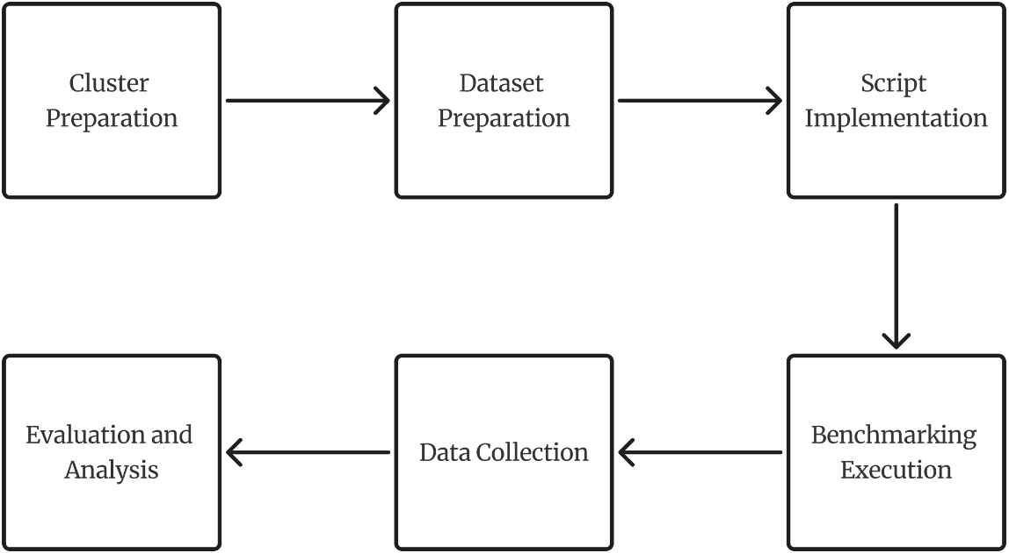

Figure 3.1 Stages of Research Flowchart
The sequential stages of the research are defined as follows:
- Cluster Initialization and Storage Configuration: Configuring a master-worker topology using commodity hardware in the IoT Laboratory. Python environments and the latest stable versions of Spark, H2O, Dask, and Ray are installed identically across all nodes. Besides that, Apache Hadoop (HDFS) is deployed across the cluster to serve as the centralized distributed storage. The HEPMASS dataset is uploaded into HDFS with a replication factor configured to ensure data redundancy and parallel read-access for all worker nodes during the execution phase.
- Dataset Preparation: The HEPMASS dataset is downloaded and systematically partitioned into four workload tiers: Light (500 rows), Moderate (1 million rows), Standard (10 MB), and Extreme (1024 MB) to act as a memory stress-test.
- Script Implementation: Standardized Python scripts for both Classification and Regression tasks are developed, logically identical but syntactically adapted to each framework's API.
- Execution and Telemetry Logging: The scripts are executed iteratively on the cluster. Execution time (in seconds), success status, and resource consumption (CPU/RAM) are automatically logged. The script will be run in different configurations of the machine, like shown in figure 3.2.

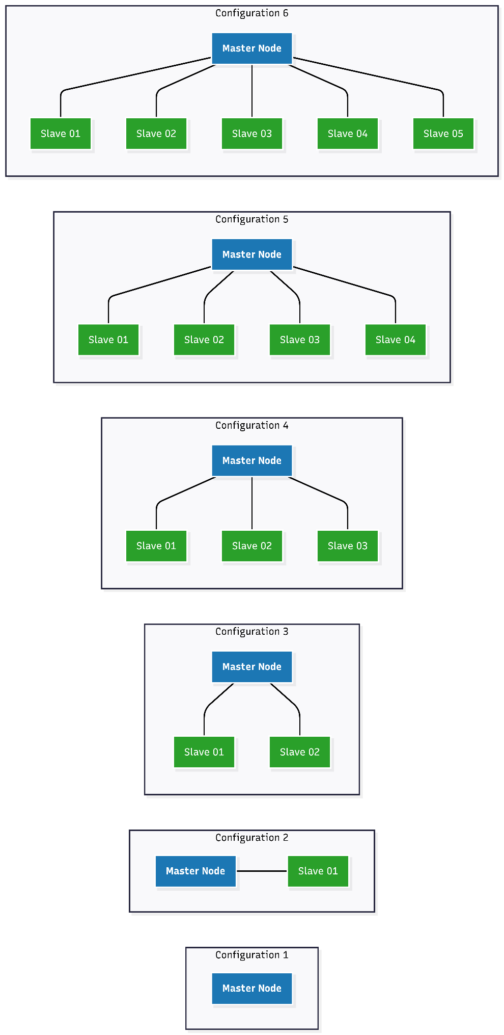
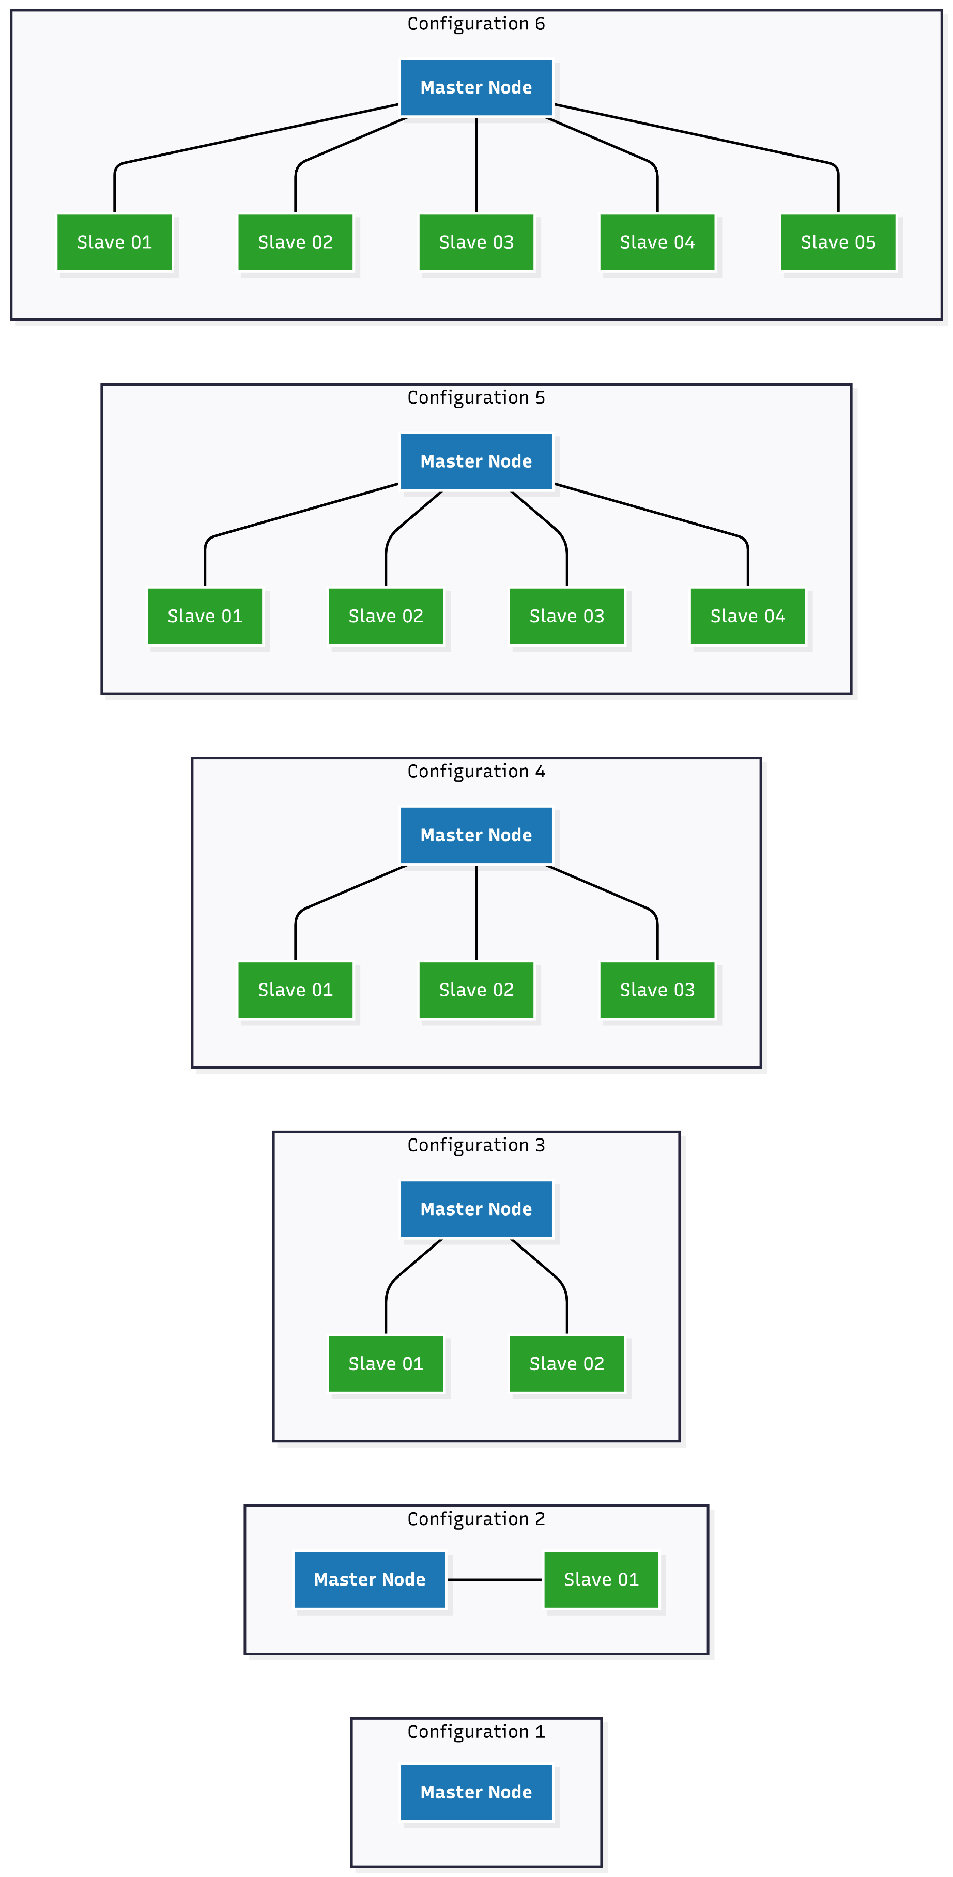
Figure 3.2 Combinations of Configurations of the Execution
- Data Aggregation and Imputation: Raw data is collected. Failed executions (e.g., due to Out-of-Memory crashes) are penalized using the PAR-10 methodology (assigned a runtime 10 times the maximum successful execution) to prevent statistical bias.
- Inferential Statistical Analysis: The aggregated data is first subjected to the Friedman Test to detect global median differences. If significant, the Pairwise Wilcoxon Signed-Rank Test with Holm-Bonferroni correction is applied to definitively rank framework performance.

3.6 Execution and Data Collection Procedures
The data collection process follows a strict, systematic experimental matrix to ensure a comprehensive and unbiased benchmarking evaluation. The procedure involves executing standardized machine learning scripts to perform identical classification and regression tasks using the evaluated frameworks (Apache Spark, H2O, Dask, and Ray) on the HEPMASS dataset.
To capture a robust performance profile, the execution phase is structured around 4 different dataset partitions (500 rows, 1 million rows, 10MB, 1024MB) and executed under 6 distinct operational configurations like shown in Figure 3.2. For the classification task, running the 4 dataset partitions across these 6 configurations will systematically generate exactly 24 execution time data points for each framework. Similarly, the regression task will follow the exact same experimental matrix (6 configurations $×$ 4 dataset partitions), yielding an additional 24 execution time data points per framework.
During this execution matrix, the runtime for each task will be recorded automatically using internal programmatic logging mechanisms, specifically utilizing Python's time module for high-precision tracking. In instances of execution failure, such as Out-of-Memory (OOM) errors, fatal kernel crashes, or exceeding the predetermined timeout threshold, the event will be explicitly documented and classified as a failed run (0% success). This structured collection procedure ensures that both the raw execution speed and the absolute computational reliability are accurately captured to be processed in the subsequent PAR-10 penalization and statistical analysis stages. To address the operational realities of commodity hardware, qualitative observations will be systematically documented during this execution phase. These observations specifically track the tuning complexity required to deploy each framework successfully and analyze the memory pressure and spilling behavior leading up to any OOM crashes.

3.7 Data Analysis Procedures
The raw data collected from the execution logs will be analyzed using a rigorous four-stage quantitative methodology, which is conducted one by one, from Success Rate Calculation, Geometric Mean of Speedup with PAR-10 Penalization, Dolan–Moré Performance Profile Construction, and inferential statistical testing by using Friedman Test for the Omnibus Test, and Pairwise Wilcoxon with Holm-Bonferroni for the Post-Hoc Analysis.

3.7.1 Success Rate Calculation
The proportion of successful executions for each framework across all dataset sizes will be computed. This serves as the primary indicator of framework robustness against Out-of-Memory (OOM) errors and execution crashes.

3.7.2 Geometric Mean of Speedup (GMS) with PAR-10 Penalization
To ensure unbiased performance aggregation, failed runs are first penalized using the PAR-10 scheme, where each failure is assigned a runtime equal to 10 times the maximum successful execution time found in the experiment. Speedup ratios are then calculated relative to the baseline framework, and the Geometric Mean is used to aggregate these ratios across datasets, providing a mathematically sound measure of average performance improvement.

3.7.3 Dolan–Moré Performance Profile Construction
Performance ratios will be plotted into cumulative distribution graphs to visually assess the probability that a framework performs within a factor $τ$ of the best result. This enables a simultaneous visual evaluation of both efficiency (execution speed) and robustness (success rate).

3.7.4 Inferential Statistical Testing (Hypothesis Testing)
To validate the results statistically, a two-step testing procedure is applied:
- Step 1: Omnibus Test (Friedman Test)
The Friedman Test is employed as the global test to determine if there are any statistically significant differences in the median execution times among the four frameworks (Spark, H2O, Dask, and Ray). This non-parametric test is selected because execution time distributions in distributed systems typically do not follow a normal distribution.
- Step 2: Post-Hoc Analysis (Pairwise Wilcoxon with Holm-Bonferroni)
If the omnibus test rejects the null hypothesis $(p < 0.05)$, a Pairwise Wilcoxon Signed-Rank Test is conducted to determine exactly which framework outperforms another. To control the Family-Wise Error Rate (Type I error) arising from multiple pairwise comparisons, the Holm-Bonferroni correction is applied to dynamically adjust the significance thresholds $(α)$.
Through this multi-stage quantitative analysis, the study aims to produce scientifically rigorous and evidence-based conclusions regarding the optimal distributed computing framework for the IoT Laboratory cluster at FTK Undiksha.

3.7.5 Justification of the Analytical Workflow
The data analysis stages in this study are structured hierarchically following a "Descriptive-to-Inferential" logic to ensure a holistic and unbiased evaluation. The analysis commences with the calculation of the Success Rate as a fundamental filter, based on the rationale that speed metrics are rendered irrelevant if a framework fails to complete the task due to crashes or Out-of-Memory (OOM) errors. Once framework viability is verified, the analysis proceeds to performance aggregation using the Geometric Mean of Speedup (GMS) integrated with the PAR-10 penalty scheme. This penalty is strictly applied prior to the mean calculation to ensure that system instability significantly impacts the final score, thereby preventing bias arising from executions that are fast yet unreliable (Bischl et al., 2016).
Next, Dolan–Moré Performance Profiles are constructed to visualize performance distributions often obscured by single summary statistics, enabling the simultaneous evaluation of efficiency and consistency across varying dataset sizes (Dolan & Moré, 2002). Finally, the validity of all findings is conclusively established through hierarchical inferential statistical testing using the Friedman Test and the Pairwise Wilcoxon Signed-Rank Test. This final stage serves as the definitive mathematical validation to confirm that observed performance differences are statistically significant rather than attributed to random noise within the computing cluster, thereby yielding scientifically robust recommendations (Demšar, 2006).

3.8 Threats to Validity
To ensure objective interpretation, several methodological limitations regarding framework architectures must be acknowledged.
- Apache Spark possesses native, highly optimized integration with the Hadoop Distributed File System (HDFS). These grants Spark an inherent data I/O advantage over Dask and Ray, which rely on external wrapper libraries (such as PyArrow) to retrieve data blocks (Zaharia et al., 2016).
- Ray is fundamentally optimized for managing stateful distributed applications, Reinforcement Learning, and deep learning pipelines (Moritz et al., 2018). Benchmarking Ray using standard tabular machine learning tasks may introduce a workload-mismatch bias, as it evaluates the framework outside its primary, AI-centric design parameters.

3.9 Research Schedule
This schedule in table 3.2 is created in order to manage and maintain the workload and efficiency of the author and research purposes. Considering the workload, and to anticipate errors during the research, this research is targeted to be done in 1 month. However, this may be changing as the time goes by.

Table 3.2 Research Schedule
No | Activity | Week 1 | Week 2 | Week 3 | Week 4 | Additional Notes
1. | Cluster Preparation |  |  |  |  | Building cluster from scratch
2. | Dataset Preparation |  |  |  |  | Preparing segmentation of the dataset
3. | Script Implementation |  |  |  |  | Implement the script in the cluster
4. | Benchmarking Execution |  |  |  |  | Including try and error of the script
5. | Data Collection |  |  |  |  | Automatically collected while running benchmark
6. | Evaluation and Analysis |  |  |  |  | Evaluate the script, and analyze using methods that already prepared before

CHAPTER 4
RESULTS AND DISCUSSION

4.1 Cluster Infrastructure and Experimental Environment
Figure 4.1 and Figure 4.2 illustrate the physical implementation and network topology of the heterogeneous commodity computing cluster deployed within the IoT Laboratory at Universitas Pendidikan Ganesha. As depicted in Figure 4.1, the cluster is constructed using standard desktop personal computers (PCs). This configuration intentionally simulates an imbalanced distributed system.
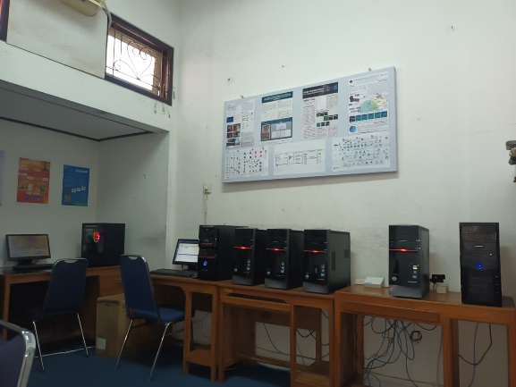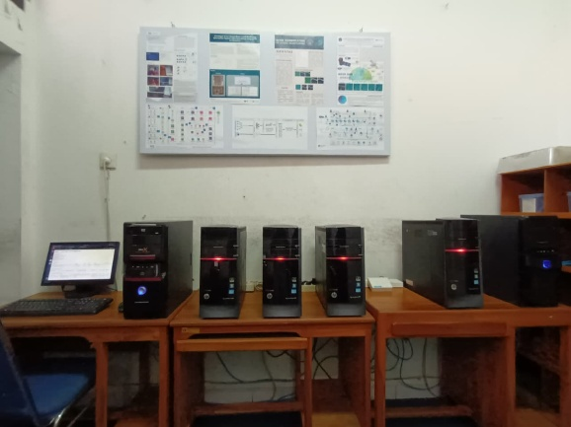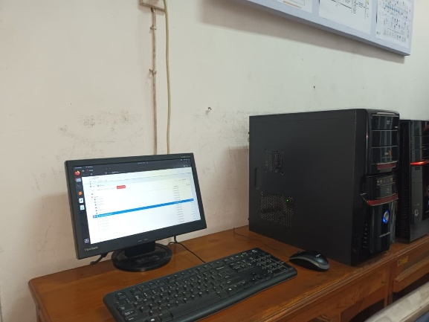

Figure 4.1 Physical Implementation of the Heterogeneous Commodity Cluster
Beyond the computational hardware, the network infrastructure connecting these nodes significantly contributes to the resource-constrained nature of the experiment. As illustrated in Figure 4.2, rather than utilizing an enterprise-grade, high-capacity centralized switch, the cluster's Local Area Network (LAN) is
facilitated by three interconnected MikroTik RouterBoard devices (specifically the hAP lite series) configured in a cascaded or daisy-chained topology. The primary router, positioned at the top-left, connects directly to the Master Node and serves as the main data gateway. Due to the limited port availability on each individual device, accommodating all five worker nodes required this primary router to be linked to a secondary router at the top-right. Subsequently, this secondary unit is cascaded to a tertiary router positioned at the bottom.
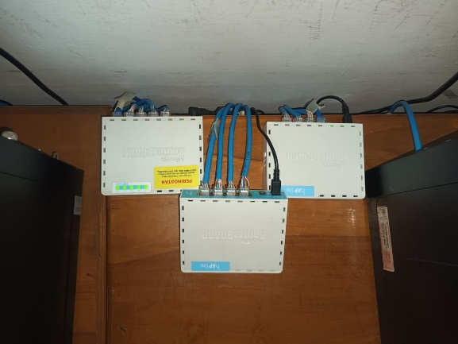

Figure 4.2 Cascaded Network Topology Utilizing Interconnected Commodity Routers
This specific multi-hop routing architecture is a critical defining characteristic of this commodity benchmark. Unlike data center networks that provide uniform, low-latency communication across all nodes via a single-tier switch, this cascaded setup introduces inherent micro-latencies and unequal network hops. During memory-intensive machine learning operations—such as massive distributed data shuffling in Apache Spark or dynamic task scheduling in Dask—the data packets must traverse multiple router interfaces, intentionally creating minor network bottlenecks. This imperfect physical and network architecture perfectly encapsulates the realistic, budget-constrained conditions often encountered in academic laboratories, ensuring that the evaluated frameworks are rigorously tested for their fault tolerance, data serialization efficiency, and network resiliency under highly suboptimal conditions.

4.2 Framework Reliability and Success Rate
The primary bottleneck when deploying distributed computing on commodity hardware is the severe physical limitation of memory, which frequently precipitates fatal Out-of-Memory (OOM) failures. Consequently, the operational reliability of each framework was strictly measured by calculating the percentage of tasks successfully completed across all dataset sizes and machine learning workloads without triggering kernel-level OOM interventions or execution timeouts. Documenting this dichotomy between successful completions and catastrophic failures is imperative, as evaluating frameworks exclusively on raw computational speed often masks their underlying architectural instabilities when subjected to extreme memory pressure.

Table 4.1 Framework Reliability and Success Rate
Framework | Total Evaluated Framework | Successful Completions | Failed (OOM) Tasks | Success Rate
Apache Spark | 24 | 23 | 1 | 95.83%
Dask | 24 | 22 | 2 | 93.75%
H2O | 24 | 22 | 2 | 91.67%
Ray | 24 | 20 | 4 | 83.33%
As presented in Table 4.1, Apache Spark exhibited near-perfect computational stability with a 95.83% success rate. This superior fault tolerance is largely attributed to Spark's robust JVM-based Tungsten execution engine, which aggressively optimizes off-heap memory and efficiently spills intermediate data partitions to the disk when RAM thresholds are breached. Dask and H2O demonstrated highly stable performance with success rates of 93.75% and 91.67%, respectively. In contrast, Ray demonstrated the highest vulnerability to memory saturation (83.33% success rate). Ray’s underlying C++ object store employs an aggressive, unmanaged in-memory allocation paradigm that struggles to adapt to the strict 4 GB RAM boundaries per node, inevitably leading to systemic Linux OOM-killer terminations.

4.3 Parallel Scalability (GMS) Analysis
To evaluate the scaling efficiency of the frameworks, the transition from a localized single-node execution (Master-only) to a fully distributed 5-node cluster was analyzed using the Geometric Mean of Speedup (GMS). Prior to this calculation, the raw execution times were strictly adjusted using the PAR-10 penalty scheme to ensure that catastrophic system crashes and Out-of-Memory (OOM) failures were mathematically penalized rather than merely ignored. By integrating these severe penalties into the GMS evaluation, the resulting metric provides a highly realistic representation of parallel scalability that simultaneously accounts for both computational acceleration and architectural fault tolerance under commodity hardware constraints.

Table 4.2 Geometric Mean of Speedup (PAR-10 Adjusted)
Framework | Geometric Mean of Speedup (GMS)
Apache Spark | 7.94x Speedup (PAR-10 Adjusted)
Dask | 3.55x Speedup (PAR-10 Adjusted)
H2O | 3.08x Speedup (PAR-10 Adjusted)
Ray | 1.64x Speedup (PAR-10 Adjusted)
Apache Spark achieved a superlinear geometric speedup of 7.94x. This exceptional scaling phenomenon occurs because the Master-only execution suffers from severe disk-paging and memory swapping (thrashing) due to resource starvation. Distributing the dataset across 5 worker nodes aggregates the memory pool, allowing Spark to process the datasets entirely in-memory and bypass heavy disk latency. Dask and H2O demonstrated moderate scalability (3.55x and 3.08x). Ray achieved the lowest GMS at 1.64x, indicating that its cluster initialization, actor-based synchronization overhead, and frequent failure penalties severely degrade its parallel efficiency on commodity-scale workloads.

4.4 Dolan-Moré Performance Profiles
The relative computational efficiency and operational robustness of the evaluated frameworks across all cluster configurations (spanning from memory-starved Master-Only environments to the fully distributed 5-Slave topology) are comprehensively visualized using Dolan-Moré performance profiles based on PAR-10 adjusted runtimes. This probabilistic visualization method plots the cumulative distribution function of the performance ratio, enabling a simultaneous comparison of both execution speed and task reliability across multiple problem instances. As illustrated in Figure 4.3, the empirical profile curves reveal a distinct architectural trade-off between raw computational velocity and overall system resilience under volatile hardware constraints. By systematically analyzing the initial vertical intercepts and the extended horizontal trajectories of these curves, the specific strengths and vulnerabilities of each framework become mathematically evident.
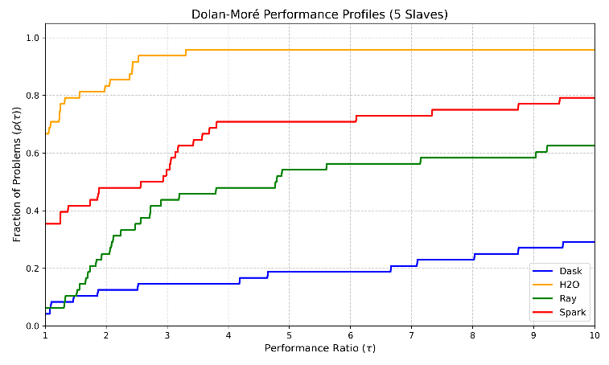

Figure 4.3 Dolan-Moré Performance Profiles (5 Slaves)
The H2O framework demonstrates outstanding baseline speed when memory thresholds are sufficient, initiating at the highest vertical intercept where the performance ratio $τ=1$. This positioning indicates that H2O achieves the absolute fastest execution time in approximately 60% of the tested problem instances, highlighting the exceptional mathematical efficiency of its highly compressed in-memory distributed key-value store. However, as the performance ratio $τ$ scales outward, the H2O curve plateaus and fails to reach a cumulative probability of 1.0. This limitation arises because H2O succumbs to fatal Out-of-Memory (OOM) exceptions during single-node executions under severe memory saturation, thereby incurring heavy PAR-10 penalization factors that depress its long-term reliability metrics across the entire experimental matrix.
Apache Spark exhibits a highly robust and stable trajectory throughout the cumulative evaluation. Although Spark initiates at a lower probability intercept for absolute speed compared to H2O at $τ=1$, its curve steadily ascends and successfully encapsulates a higher proportion of resolved workloads at extended performance ratios. This behavior mathematically validates Spark’s superior fault tolerance and low-level memory regulation. By aggressively leveraging off-heap memory management via the Tungsten Engine and deploying proactive data partition spilling to the physical mechanical disks, Spark safely navigates critical memory shortages without triggering kernel-level terminations. Consequently, the profile demonstrates that while H2O functions as an exceptional speed-optimized engine when adequate distributed resources are guaranteed, Apache Spark establishes itself as the most viable and dependable framework for maintaining operational continuity across unpredictable and severely constrained commodity hardware environments.

4.5 Inferential Statistical Analysis
To conclusively determine if the observed performance differences are statistically significant and not merely the result of random experimental variance, a rigorous two-stage inferential statistical evaluation was conducted. Due to the non-normal distribution of the execution runtimes and the deliberate inclusion of extreme PAR-10 outliers resulting from Out-of-Memory failures, non-parametric mathematical models were strictly utilized for this assessment. This systematic approach consists of an initial omnibus Friedman test to identify global performance disparities across all engines, followed by a post-hoc Wilcoxon signed-rank test to precisely establish which frameworks are statistically equivalent at the highest performance echelon.

4.5.1 Omnibus Test: Friedman Test
Given the repeated measures design of the experiment, where all frameworks executed identical dataset and workload combinations, the Friedman test was utilized to evaluate the existence of global performance differences. This non-parametric omnibus test is specifically selected because it evaluates the ranks of framework performance across all experimental blocks, rather than relying on raw mean values that are susceptible to extreme PAR-10 outliers. By employing this method, the study systematically assesses whether the performance variance observed among the four frameworks is statistically significant or merely attributable to random experimental noise. Consequently, the Friedman test serves as the mandatory initial step to determine if at least one framework performs differently from the others before proceeding to granular pairwise comparisons.
- Friedman Statistic Value: 19.3500
- P-Value: 0.0002
Since the calculated p-value (0.0002) is substantially lower than the pre-defined alpha threshold of 0.05, the null hypothesis (which posits that all frameworks perform identically) is firmly rejected. It is therefore statistically concluded that there is a highly significant overall performance disparity among the four frameworks. This result provides the necessary empirical justification to proceed with granular post-hoc testing, as it confirms that the observed performance variations are not merely the result of random experimental noise.

4.5.2 Post-Hoc Analysis: Pairwise Wilcoxon Signed-Rank Test
Following the significant outcome of the Friedman test, a Pairwise Wilcoxon Signed-Rank Test (augmented with the Holm-Bonferroni correction) was systematically applied to perform head-to-head comparisons between all evaluated frameworks. This post-hoc procedure is essential to isolate specific performance disparities, as the omnibus test only confirms the existence of global variance without pinpointing which framework pairs differ significantly. By utilizing the Holm-Bonferroni correction, the analysis effectively mitigates the risk of Type I errors (false positives) that inherently accumulate during multiple simultaneous hypothesis testing. Consequently, this granular analysis enables a precise determination of performance equivalence among the frameworks, thereby establishing which engines belong to the top-tier performance echelon within this commodity hardware environment.

Table 4.3 Pairwise Wilcoxon Signed-Rank Test Results (Holm Adjusted)
Pairwise Comparison | P-Value (Real) | P-Value (Holm) | Significance $(α = 0.05)$
Dask vs H2O | 0.0078 | 0.0469 | Significant (H2O Wins)
Dask vs Ray | 0.3828 | 0.7656 | Not Significant (Equivalent)
Dask vs Spark | 0.0078 | 0.0469 | Significant (Spark Wins)
H2O vs Ray | 0.0078 | 0.0469 | Significant (H2O Wins)
H2O vs Spark | 0.9453 | 0.9453 | Not Significant (Equivalent)
Ray vs Spark | 0.0078 | 0.0469 | Significant (Spark Wins)
The post-hoc analysis reveals a critical architectural insight. While Apache Spark appeared to heavily dominate visually in the GMS and Dolan-Moré profiles, the pairwise comparison between H2O and Spark yields an adjusted p-value of 0.9453. This indicates that their overall performance consistency across the cluster is statistically equivalent. Both Spark and H2O significantly outperform Dask and Ray. Dask and Ray are proven to be statistically equivalent (p-value = 0.7656), placing them in a secondary tier of performance within this specific commodity hardware environment.

4.6 Setup Complexity and Operational Usability
A critical qualitative metric for evaluating distributed computing frameworks, particularly in academic or educational contexts, is the deployment complexity and human operational effort required for successful cluster initialization. As Dask and Ray are inherently Python-native frameworks, they exhibit significant advantages regarding ease of setup on commodity hardware. Installation across all worker nodes is executed rapidly using the standard Python package manager (pip), and the dynamic initialization between the central scheduler and distributed workers requires only standard terminal commands without intricate external dependencies. Apache Spark and H2O demand a considerably more intensive configuration phase due to their underlying Java Virtual Machine (JVM) dependencies. Cluster administrators must ensure synchronized Java Development Kit (JDK) versions, manually manage complex environmental variables across all heterogeneous nodes, and configure strict network access permissions, substantially increasing the operational overhead during initial deployment.
Beyond the setup complexity, the API learning curve and code migration efficiency from traditional local data science libraries, such as Pandas and NumPy, are vital for practical framework adoption. Dask registers highly favorable metrics in this parameter as its core architecture deliberately replicates Pandas DataFrame and NumPy array syntax, thereby minimizing the code rewrite time for researchers transitioning from local computations to a distributed distributed model. PySpark offers a mature API and massive documentation repository, although it still requires understanding distinct distributed DataFrame paradigms that differ from pure Python ecosystems. H2O provides a uniquely advantageous approach for machine learning tasks by wrapping distributed modeling processes into a high-level automated machine learning (AutoML) API. This abstraction allows instant deployment of complex classification and regression models without structural coding, though its inherent lack of flexibility becomes apparent when handling highly customized data manipulations. In contrast, Ray demands the most radical shift, requiring the adoption of the Actor Model and remote decorator (@ray.remote) paradigms, which necessitates significant code restructuring.
Ecosystem maturity and real-time monitoring tools are pivotal for maintaining cluster stability under extreme memory pressure. Apache Spark and Dask provide exceptionally mature, informative Web UIs that allow real-time tracking of memory allocation, task graph progress, and bottleneck detection across heterogeneous nodes. H2O monitoring is similarly supported by the interactive H2O Flow visual interface. While Ray features a modern dashboard, it frequently loses synchronization or suffers total failures when worker nodes experience stochastic OOM terminations during extreme stress tests on 4GB-RAM hardware. In conclusion, despite the modern flexibility and adaptability inherent in Dask and Ray, Apache Spark continues to lead regarding documentation maturity, operational reliability, and monitoring stability, rendering it the most predictable platform for academic research deployments.

4.7 Holistic Discussion of Experimental Findings
The overall experimental results provide a profound understanding of the performance dynamics of distributed computing frameworks when pushed to the critical boundaries of commodity hardware. The synthesis of task success rates, parallel scalability efficiency, performance profiling, and inferential testing asserts that evaluating frameworks solely on execution latency provides an incomplete narrative, and hardware resilience must be prioritized.
A critical scientific contribution of this study is the identification of a fundamental architectural trade-off. Based on the all-configuration Dolan-Moré visualization, H2O operates as the definitive speed winner. By leveraging a highly compressed distributed key-value store architecture, H2O achieves unmatched computational velocity across the majority of workloads when cluster resources are sufficient to prevent system failure. However, the empirical insights simultaneously confirm that Apache Spark stands out as the ultimate resilience winner. Spark’s capability to dominate the overall success rate at 95.83% and achieve a 7.94x superlinear speedup proves that its hybrid memory approach (combining off-heap memory optimization via the Tungsten Engine and aggressive disk spilling) successfully mitigates catastrophic data shuffling failures when individual nodes experience acute memory starvation.
This empirical reality directly addresses the initial hypothesis gap formed prior to the evaluation. Initially, it was posited that Dask would emerge as the most optimal framework for the heavily constrained 4 GB RAM commodity cluster. This assumption was based on Dask’s lightweight, Python-native architecture and its out-of-core computing capabilities, which theoretically allow it to process datasets larger than available memory by paging to the mechanical disk. However, the empirical results consistently placed Dask in the secondary performance tier. The architectural anomaly between the initial hypothesis and the actual results is primarily attributed to memory management under extreme data shuffling. While Dask's task graph scheduling is efficient for moderate operations, the massive node communication required by tree-based ensemble algorithms induces heavy Python serialization overhead. Dask's reliance on standard garbage collection struggles to release memory fast enough, eventually triggering Out-of-Memory (OOM) failures. In contrast, Spark's Tungsten engine bypasses these limitations by explicitly allocating off-heap memory, proving far more robust.
The two-stage inferential statistical analysis mathematically validates this performance constellation. The post-hoc Wilcoxon signed-rank test uncovers a powerful statistical equivalence between Apache Spark and H2O, yielding an adjusted p-value of 0.9453. This finding formally places Spark and H2O within the same top-tier performance echelon, separating them significantly from the secondary tier occupied by Dask and Ray. Ray, similar to Dask, suffered from unmanaged C++ Plasma object store allocations, leading to cascading node failures. Ultimately, this holistic synthesis demonstrates that for replicating distributed pipelines on commodity academic hardware, selection priorities must focus on strict memory regulation and mature fault tolerance, positioning Apache Spark and H2O as the only viable solutions.

CHAPTER 5
CONCLUSION AND RECOMMENDATIONS

5.1 Conclusion
Based on the comprehensive benchmarking methodologies and inferential statistical analyses conducted in the IoT Laboratory at FTK Undiksha, the following conclusions are drawn to directly answer the research problem statements:
- Apache Spark demonstrated the highest operational resilience and success rate (95.83%) when executing memory-intensive classification and regression tasks on commodity hardware. By leveraging off-heap memory optimization via the Tungsten engine and aggressive disk spilling, Spark successfully bypassed Out-of-Memory (OOM) anomalies that severely affected unmanaged architectures like Ray (83.33%).
- When execution failures were heavily penalized using the PAR-10 methodology, Apache Spark emerged as the most scalable framework, achieving a superlinear Geometric Mean of Speedup (GMS) of 7.94x. This scalability heavily outperformed Dask (3.55x), H2O (3.08x), and Ray (1.64x), primarily because Spark successfully mitigated severe single-node memory starvation (thrashing) prior to cluster distribution.
- The Dolan-Moré performance profiles visually uncovered a critical architectural trade-off between absolute velocity and system robustness. H2O operates as the definitive speed winner, achieving the fastest execution time in approximately 60% of the evaluated scenarios when distributed memory pools are adequate. Apache Spark establishes itself as the ultimate resilience winner, demonstrating the highest capacity to continuously
resolve workloads across unpredictable configurations without incurring fatal OOM penalties.
- The Friedman omnibus test mathematically confirmed a highly significant global performance difference across the frameworks (p-value = 0.0002). The post-hoc Pairwise Wilcoxon test with Holm-Bonferroni correction revealed that Apache Spark and H2O are statistically equivalent in the top-tier performance echelon (adjusted p-value = 0.9453), and both significantly outperform the secondary tier occupied by Dask and Ray.
- For small-scale machine learning research deployments at FTK Undiksha utilizing heavily constrained commodity hardware, a hybrid framework deployment strategy is highly recommended. Infrastructure management should prioritize H2O for velocity-centric in-memory processing when cluster resources are sufficient, while strictly relying on Apache Spark as the robust, fault-tolerant backbone for heavy data-shuffling operations under extreme hardware limitations.

5.2 Recommendation
Based on the empirical findings and limitations of this study, the following recommendations are proposed for future academic deployments and subsequent research:
- Laboratory administrators and students should prioritize the deployment of Apache Spark or H2O for massive data analytics tasks. To prevent the 100% CPU and RAM utilization bottlenecks observed in this study, it is recommended to explicitly configure JVM memory limits (spark.executor.memory) and implement strict data partitioning before initiating cluster-wide operations.
- Future studies should expand the scope of this benchmark by implementing algorithmic hyperparameter tuning tailored specifically for resource-constrained environments. Additionally, evaluating these frameworks using advanced deep learning workloads (such as convolutional architectures for spatial image segmentation or federated learning models) and real-time streaming data processing paradigms from IoT sensor networks would provide profound further insights into their architectural versatility.

REFERENCES

Al-Jody, T., Aagela, H., & Holmes, V. (2021). Inspiring the Next Generation of HPC Engineers with Reconfigurable, Multi-Tenant Resources for Teaching and Research. Sustainability, 13(21), 11782. https://doi.org/10.3390/su132111782
Aryanto, I. K. A. A., Wijaya, I. P., Hendrawan, I. N. R., & Aryanto, K. Y. E. (2021). A Prototype IoT based Technology for Body Temperature Monitoring. 2021 3rd International Conference on Cybernetics and Intelligent System (ICORIS), 1–6. https://doi.org/10.1109/ICORIS52787.2021.9649631
Barrera-García, J., Cisternas-Caneo, F., Crawford, B., Gómez Sánchez, M., & Soto, R. (2024). Feature Selection Problem and Metaheuristics: A Systematic Literature Review about Its Formulation, Evaluation and Applications. In Biomimetics (Vol. 9, Number 1, p. 9). Multidisciplinary Digital Publishing Institute (MDPI). https://doi.org/10.3390/biomimetics9010009
Bin Yusof, Z. (2023). Architectural Advancements in Big Data Analytics: A Comparative Study of Scalable Frameworks for High-Performance Computing. Orient Journal of Emerging Paradigms in Artificial Intelligence and Autonomous Systems.
Bischl, B., Kerschke, P., Kotthoff, L., Lindauer, M., Malitsky, Y., Fréchette, A., Hoos, H., Hutter, F., Leyton-Brown, K., Tierney, K., & Vanschoren, J. (2016). ASlib: A benchmark library for algorithm selection. Artificial Intelligence, 237, 41–58. https://doi.org/10.1016/j.artint.2016.04.003
Dantes, G. R., Asril, N. M., Liem, A., Suwastini, N. K. A., Keng, S.-L., & Mahayanti, N. W. S. (2024). Brief Mobile App–Based Mindfulness Intervention for Indonesian Senior High School Teachers: Protocol for a Pilot Randomized Controlled Trial. JMIR Research Protocols, 13, e56693. https://doi.org/10.2196/56693
Demšar, J. (2006). Statistical Comparisons of Classifiers over Multiple Data Sets. Journal of Machine Learning Research, 7, 1–30.
Dewi, L. J. E., Wijaya, I. N. S. W., & Seputra, K. A. (2021). Web-based Buleleng regency agriculture product information system development. Journal of Physics: Conference Series, 1810(1). https://doi.org/10.1088/1742-6596/1810/1/012029
Dewi, N. P. K., Suputra, P. H., Paramartha, A. A. G. Y., Dewi, L. J. E., Varnakovida, P., & Aryanto, K. Y. E. (2025). River Area Segmentation Using Sentinel-1 SAR Imagery with Deep-Learning Approach. Geomatics and Environmental Engineering, 19(4), 39–63. https://doi.org/10.7494/geom.2025.19.4.39
Dolan, E. D., & Moré, J. J. (2002). Benchmarking optimization software with performance profiles. Mathematical Programming, 91(2), 201–213. https://doi.org/10.1007/s101070100263
Dugré, M., Hayot-Sasson, V., & Glatard, T. (2023). Performance comparison of Dask and Apache Spark on HPC systems for neuroimaging. Concurrency and Computation: Practice and Experience, 35(21). https://doi.org/10.1002/cpe.7635
Friedman, M. (1937). The Use of Ranks to Avoid the Assumption of Normality Implicit in the Analysis of Variance. In Source: Journal of the American Statistical Association (Vol. 32, Number 200). http://www.jstor.orgURL:http://www.jstor.org/stable/2279372Accessed:08/07/200813:40
García, S., & Herrera, F. (2008). An Extension on “Statistical Comparisons of Classifiers over Multiple Data Sets” for all Pairwise Comparisons. Journal of Machine Learning Research, 9, 2677–2694.
Gupta, A., Santhiya, P., Thiyagarajan, C., Gupta, A., Gupta, M., & Dwivedi, R. Kr. (2025). The Cutting-Edge Hadoop Distributed File System: Un-leashing Optimal Performance. ICST Transactions on Scalable Information Systems, 12(5). https://doi.org/10.4108/eetsis.9027
Kumar Alam, P. (2022). Optimizing Apache Spark Structured Streaming Performance for External Data Enrichment: Balancing Latency and Throughput in Distributed Stream Processing. Sarcouncil Journal of Engineering and Computer Sciences, 1(2). https://doi.org/10.5281/zenodo.16936204
Ledell, E., & Poirier, S. (2020). H2O AutoML: Scalable Automatic Machine Learning. Proceedings of the 7th ICML Workshop on Automated Machine Learning (AutoML). https://scinet.usda.gov/user/geospatial/#tools-and-software
Liu, A.-C., & You, Y.-P. (2022). Offworker: An Offloading Framework for Parallel Web Applications. Proceedings of the International Conference on Algorithms and Architectures for Parallel Processing (ICA3PP), 170–185. https://doi.org/10.1007/978-3-031-20891-1_13
Moritz, P., Nishihara, R., Wang, S., Tumanov, A., Liaw, R., Liang, E., Elibol, M., Yang, Z., Paul, W., & Jordan, M. I. (2018). Ray: A Distributed Framework for Emerging AI Applications. 13th USENIX Symposium on Operating Systems Design and Implementation (OSDI 18), 561–577. https://www.usenix.org/conference/osdi18/presentation/nishihara
Pauloski, J. G., Rydzy, K., Hayot-Sasson, V., Foster, I., & Chard, K. (2024). Accelerating Python Applications with Dask and ProxyStore. ArXiv Preprint ArXiv:2410.12092. http://arxiv.org/abs/2410.12092
Perera, N., Sarker, A. K., Shan, K., Fetea, A., Kamburugamuve, S., Kanewala, T. A., Widanage, C., Staylor, M., Zhong, T., Abeykoon, V., von Laszewski, G., & Fox, G. (2024). Supercharging distributed computing environments for high-performance data engineering. Frontiers in High Performance Computing, 2. https://doi.org/10.3389/fhpcp.2024.1384619
Poddar, A. K., Mayank, A., Prabhu, A. S., Krishan, G. D., & P, A. K. (2025). A Survey on Distributed AI Systems: Architectures, Strategies, and Applications. 2025 International Conference on Intelligent and Secure Engineering Solutions (CISES), 291–298. https://doi.org/10.1109/CISES66934.2025.11265398
Putrama, I. M., & Martinek, P. (2024). Heterogeneous data integration: Challenges and opportunities. In Data in Brief (Vol. 56). Elsevier Inc. https://doi.org/10.1016/j.dib.2024.110853
Rocklin, M. (2015). Dask: Parallel Computation with Blocked algorithms and Task Scheduling. PROC. OF THE 14th PYTHON IN SCIENCE CONF, 130–136. https://doi.org/10.25080/Majora-7b98e3ed-013
Šajnović, U., Vošner, H. B., Završnik, J., Žlahtič, B., & Kokol, P. (2024). Internet of Things and Big Data Analytics in Preventive Healthcare: A Synthetic Review. Electronics (Switzerland), 13(18), 3642. https://doi.org/10.3390/electronics13183642
Seputra, K. A., & Dewi, L. J. E. (2022, March 30). A Design of Patient Registration Apps using Flutter, Laravel and, Vue JS. https://doi.org/10.4108/eai.27-11-2021.2315532
Setemen, K., Sudirtha, I. G., Marsiti, C. I. R., Dantes, G. R., & Suputra, P. H. (2020). Developing inventory information system using mobile computing with quick response (2d-barcode) and geotagging. Journal of Physics: Conference Series, 1516(1). https://doi.org/10.1088/1742-6596/1516/1/012011
Sibley, E. H., Fleming, P. J., & Wallace, J. J. (1986). How Not to Lie with Statistics: The Correct Way to Summarize Benchmark Results. Communications of the ACM March, 29(3), 218–221. https://doi.org/10.1145/5666.5673
Singh, A., Sandhu, R., Mehta, S., Giri, N. C., Kuziakin, O., Leliuk, S., Saprykin, R., & Dobrozhan, A. (2023). A Comparative Study of Bigdata Tools: Hadoop Vs Spark Vs Storm. 2023 IEEE 4th KhPI Week on Advanced Technology (KhPIWeek), 1–5. https://doi.org/10.1109/KhPIWeek61412.2023.10311577
Zaharia, M., Xin, R. S., Wendell, P., Das, T., Armbrust, M., Dave, A., Meng, X., Rosen, J., Venkataraman, S., Franklin, M. J., Ghodsi, A., Gonzalez, J., Shenker, S., & Stoica, I. (2016). Apache Spark: a unified engine for big data processing. Communications of the ACM, 59(11), 56–65. https://doi.org/10.1145/2934664
Zöller, M.-A., & Huber, M. F. (2021). Benchmark and Survey of Automated Machine Learning Frameworks. Journal of Artificial Intelligence Research, 70, 409–472. https://doi.org/10.1613/jair.1.11854

